**Lesson 4 APP5**

**Distribute Your App Across a Swarm Cluster**

Creating 2 instance

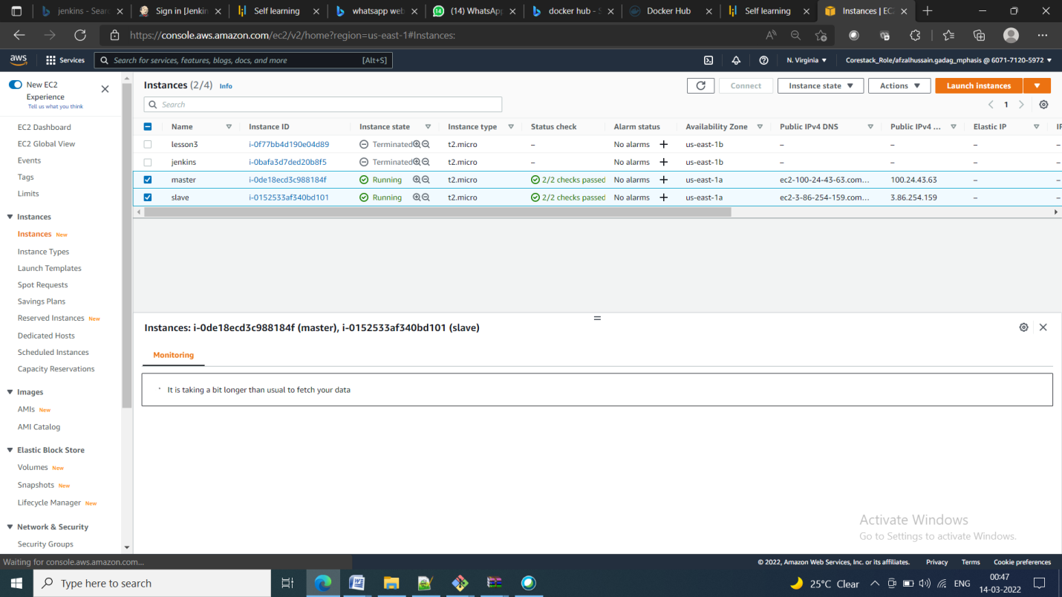

Conneting them both using docker swarm

docker swarm init

inetially master is only connected to the swarm

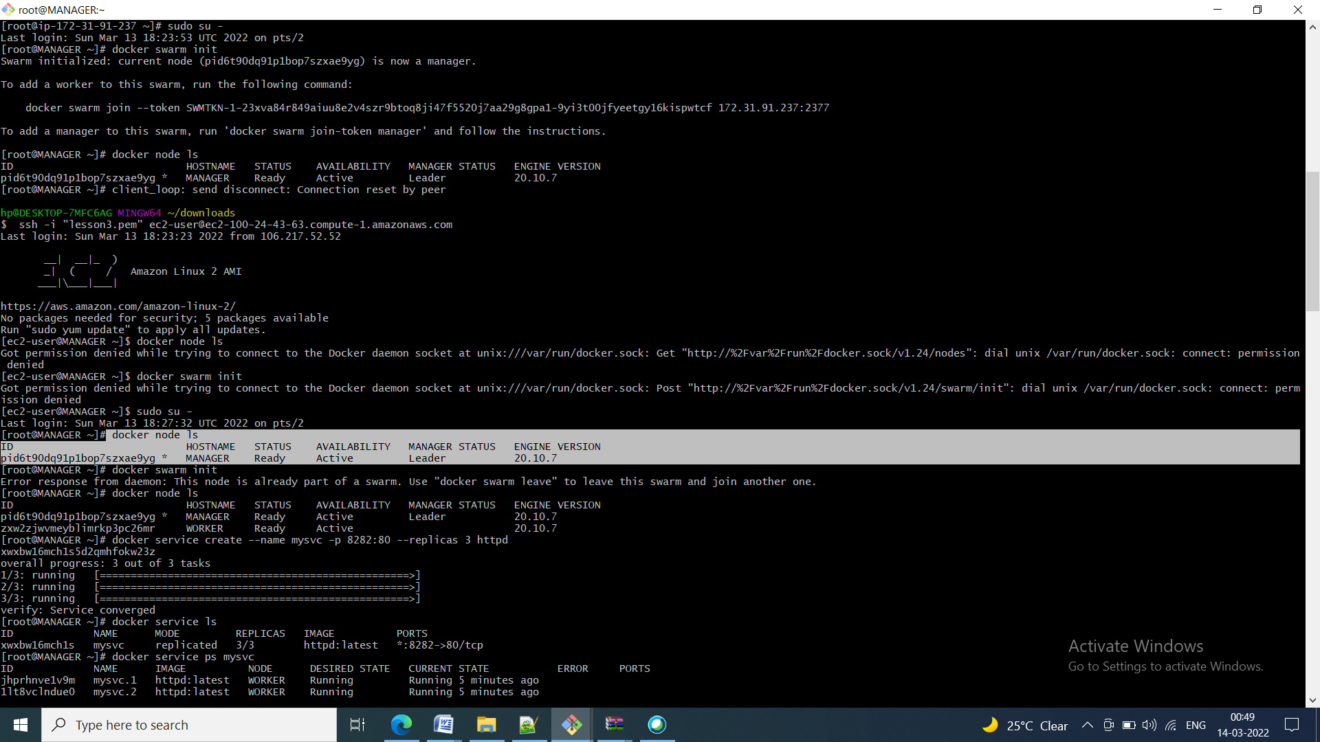

Using master token worker is connected to the master

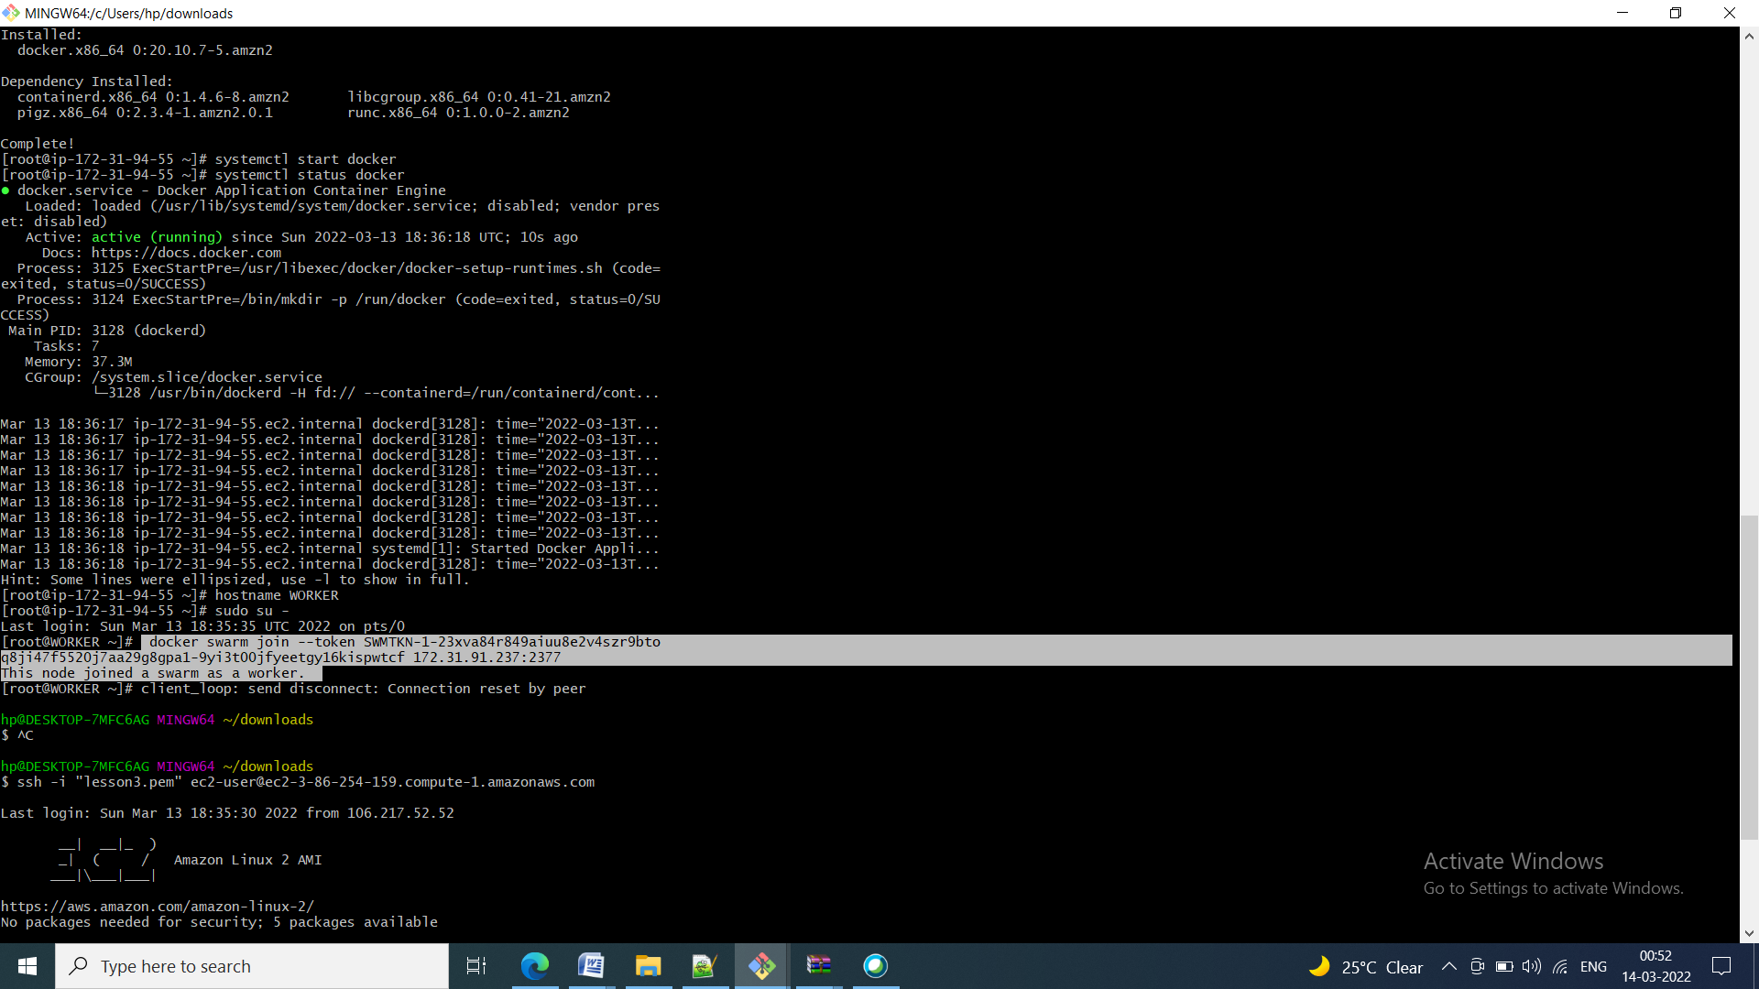

Now to instance is connected through swarm

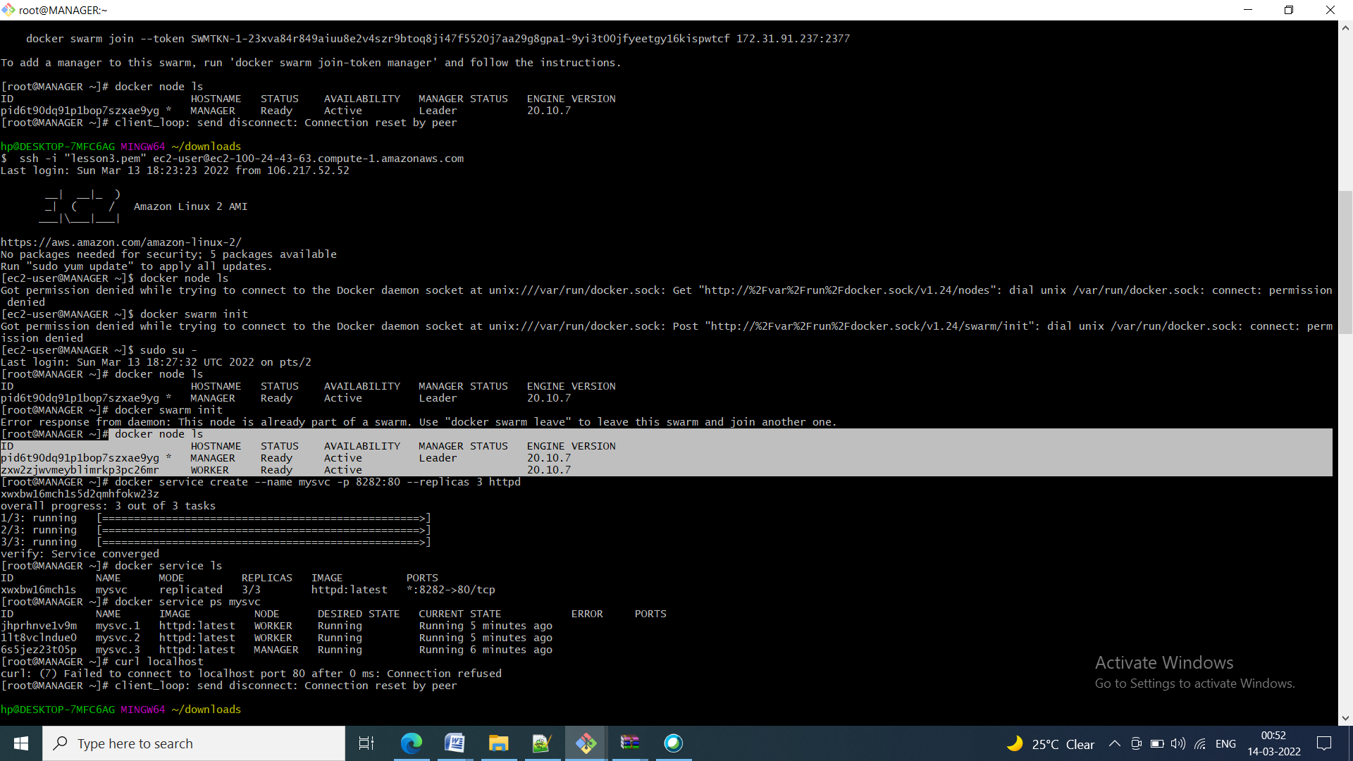

Creating the service in the swarm with some replicas

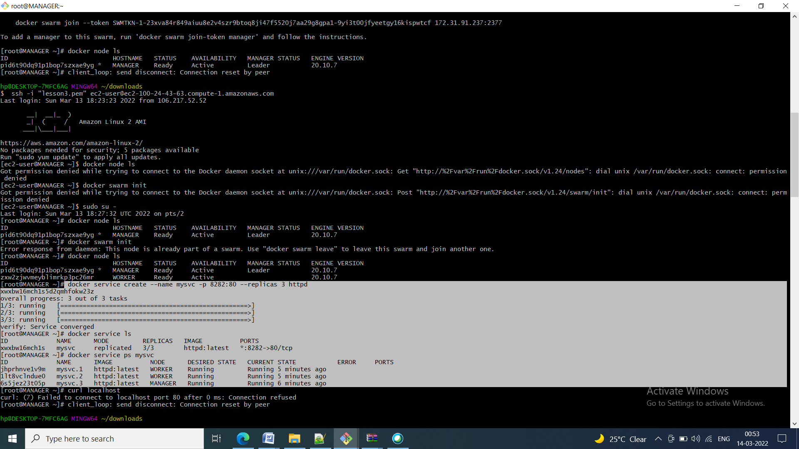

Due to swarm the image replicas have been distributed in between MANAGER and WORKER machine

